Project Documentation

FitFlex:Your Personal Fitness Companion

## 1. Introduction

• Project Title:FitFlex:Your Personal Fitness Companion

• Team ID: NM2025TMID28805

• Team Leader:P.Gayathri&gayathripanneerselvam26@gmail.com

• Team Members:

M.Abinaya&malligamaligamaha@gmail.com

S.Dharaneeswari&ds6490203@gmail.com

M.Iswarya&iswaryamurugan933&gmail.com

## 2. Project Overview

• Purpose: The News App is a React-based frontend application that fetches and displays news articles from APIs. It helps users stay updated with the latest headlines and categories in a clean and responsive interface.

• Features:

– Browse latest news headlines

– Filter by categories

– Responsive design using Bootstrap

– Navigation using React Router

– API integration with Axios

## 3. Architecture

• Frontend: React.js with Bootstrap and React Router DOM

• Backend: Not included in this project (can integrate with Node.js/Express in future)

• API: News data fetched from third-party APIs using Axios

## 4. Setup Instructions

• Prerequisites:

– Node.js

– Git

– Visual Studio Code

• Installation Steps:

# Clone the repository

git clone <repository-url>

# Install dependencies

npm install

# Start the application

npm start

## 5. Folder Structure

news-app/

|-- src/ # React source code

| |-- components/ # Reusable components

| |-- pages/ # Different pages

| |-- App.js # Main app component

|-- public/ # Static files

|-- package.json # Dependencies and scripts

## 6. Running the Application

• Frontend:

cd news-app

npm start

• Access: Visit http://localhost:3000

## 7. API Documentation

• News APIs:

– Example: https://newsapi.org/ or other configured endpoints

– Endpoints depend on integration (e.g., /top-headlines, /everything)

## 8. Authentication

• This project currently does not include authentication. Future enhancements may add JWT-based authentication for user login.

## 9. User Interface

• Landing Page: Displays top news headlines

• Category Pages: Allows browsing by categories

• Article Details Page: Shows detailed news article

## 10. Testing

• Manual testing during development

• Tools: Browser Dev Tools, Jest & React Testing Library (included)

## 11. Screenshots or Demo

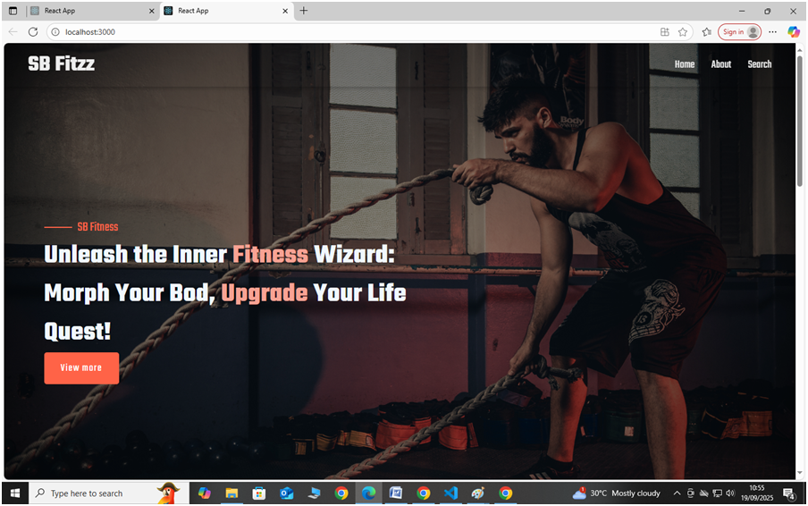

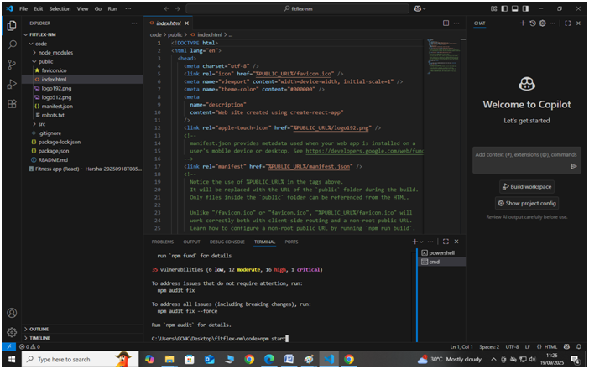

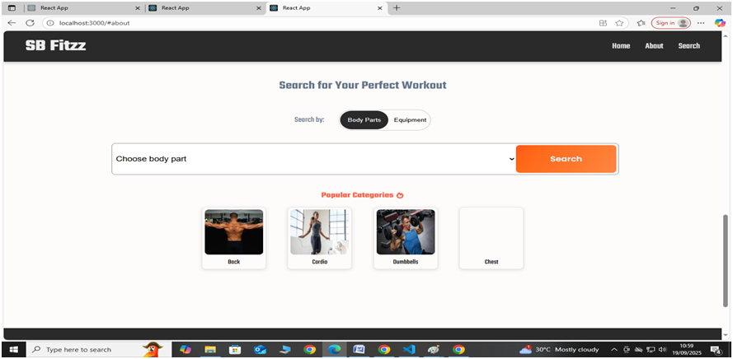

## 12. Known Issues

• Limited to frontend; no backend integration yet.

• Requires API key setup for news API.

## 13. Future Enhancements

• Add backend for user authentication and personalization.

• Add bookmarking and favorite articles feature.

• Add admin panel for content moderation.